Deploying HRMS Chatbot

Requirements for chatbot:

* Python 3.8 or above
* js, svg file and folder in the website folder
* script to run chatbot in the website's base file named ‘front_end.js’

Steps:

* Install python 3.8
* Set virtual env with python set to 3.8

*python3 -m venv env*

or

*python3.8 -m venv env*

* Activate Env:

*cd venv/*

*Source/bin/activate*

* Step out of environment:

*cd ..*

* upgrade pip:

*pip3 install -U pip*

* Install rasa:

*pip install rasa*

* Install all the requirements

*pip install -r requirements.txt*

* in 1st terminal:

*nohup rasa run --model models --enable-api --cors "*" --debug -p 5005*

to specify the port number *-p* numberis used and this above command will up the rasa server and keep it running

* in 2nd terminal:

*nohup rasa run actions*

this command will run the rasa custom actions on the action server

To change the connections and credentials of database :

For HRMS Chatbot the different connections of databases are provided in a dictionary format in file db.py. 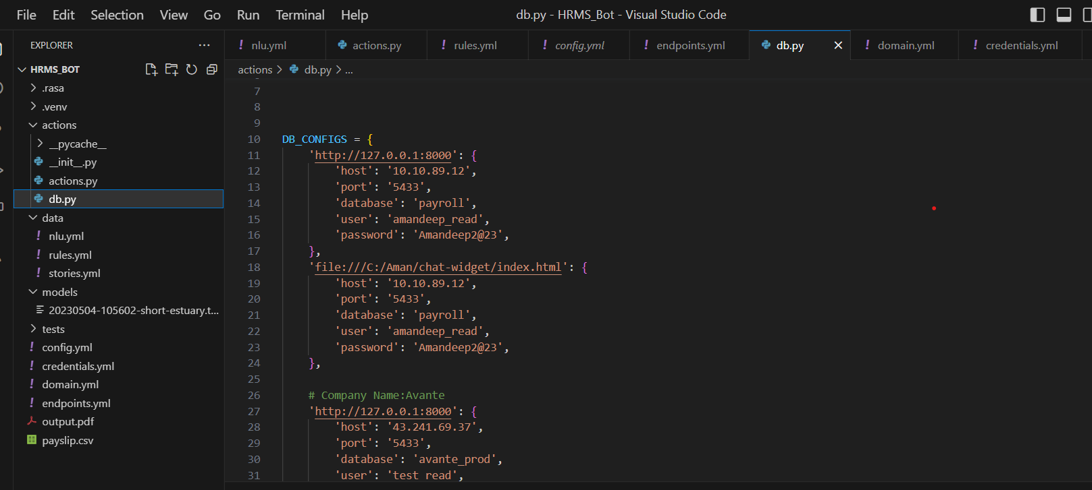

You can change the credentials of the database there.